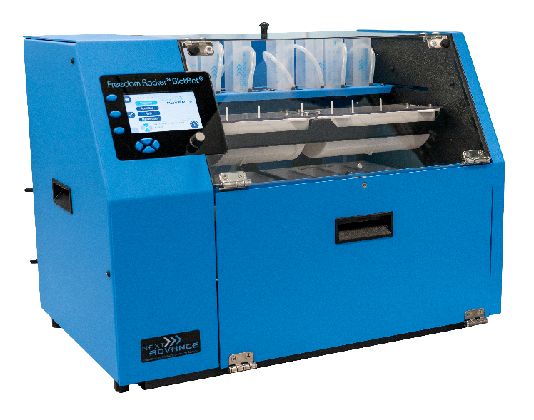Overview

The BlotBot® 240 automates gel and blot processing. With microprocessor control, it provides consistent conditions so you can incubate, stain, or wash your blots while you take care of your other tasks. BlotBot® 240 can dispense and recover individual reagents, and run 2 midi or 4 mini blots simultaneously.

Uses

* BlotBot® dispenses reagents (e.g. antibodies) of at least 3.5 mL.
* Holds 2 midi blots or 4 mini blots.
* Washes blots with buffer – selectable for each step of a protocol or manual.
* Has individual automatic reagent recovery.
* Has intuitive interface with LCD display - View and program an entire protocol in a single screen.
* Prevents drying of membrane by rocking gently after protocol completion until user arrives.

**What’s in the Box:**

* BlotBot® 240
* 2 L wash buffer bottle with tubing
* 2 Midi blot trays (each holds 1 blot)
* 2 Mini blot trays (each holds 2 blots)
* 2 Blot tray covers (fits mini and midi size trays)
* 2 Removable waste trays
* 2 Removable funnel trays
* Starter Kit – It includes the following:
  + 8 reagent recovery tubes with caps
  + 40 Reagent reservoir tubes
  + Foil seals for reagent reservoirs
  + Operator’s manual
  + Free technical support
  + 2 year warranty

Properties

|  |  |
| --- | --- |
| Description | Property |
| Programs | Save up to 8 protocols  Each protocol can have up to 9 steps  Each step can be repeated up to 10 times |
| Compatible Blots | 2 Midi (8 cm x 16 cm)  4 Mini (8 cm x 8 cm) |
| Reagents | 1 wash buffer 2 pre-loaded reagents per blot, can be recovered |
| Min Buffer Volumes | Midi Blots – 7 mL per blot  Mini Blots – 3.5 mL per blot |
| Max Buffer Volumes | Midi Blots – 150 mL per blot  Mini Blots – 75 mL per blot |
| Rocking | 5-40 rocks per minute  1 minute to 96 hours per step |
| Power | 100-240 V  50-60 Hz  1.4 Amp |
| Operating Conditions | +4°C to +40°C  5-90% relative humidity (non-condensing) |
| Dimensions | 38 cm L x 51 cm W x 43 cm H  15 in L x 20 in W x 17 in H |
| Weight | 40 lbs (18 kg) |
| Warranty | Standard 2 years; Extendable to 4 years |