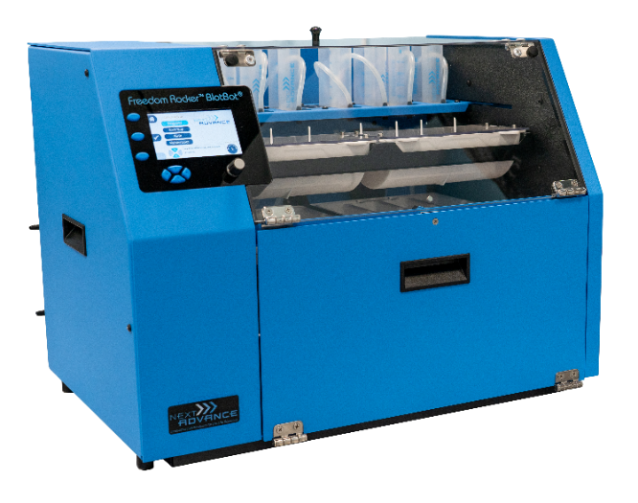Overview

The BlotBot® 248V automates gel and blot processing. With microprocessor control, it provides consistent conditions for incubating, staining, and washing gels or blots. This model provides the convenience and reliability to save you time. BlotBot® 248V can dispense and recover individual reagents, run 2 midi, 4 mini, or 8 strip blots simultaneously, and switch between two buffers.

Uses

* BlotBot® dispenses reagents (e.g. antibodies) of at least 3.5 mL.
* Holds 2 midi blots, 4 mini blots, or 8 strip blots.
* Washes blots with either of 2 buffers – selectable for each step of a protocol or manual.
* Has individual automatic reagent recovery.
* Has intuitive interface with LCD display - View and program an entire protocol in a single screen.
* Prevents drying of membrane by rocking gently after protocol completion until user arrives.

What’s in the Box:

* BlotBot® 248V
* 2 - 2L wash buffer bottle with tubing
* 2 - Midi blot trays (each holds 1 midi blot)
* 2 - Mini blot trays (each holds 2 mini blots)
* 2 - Strip trays (each holds 4 strip blots)
* 2 - Blot tray covers (fits mini and midi size trays)
* 2 - Removable waste trays
* 2 - Removable funnel trays
* Starter Kit – It includes the following:
  + 16 - Reagent recovery tubes with caps
  + 80 - Reagent reservoir tubes
  + Foil seals sample packet to resuse reagent reservoirs
  + Power supply
  + Operator’s manual
  + Free technical support

Properties

|  |  |
| --- | --- |
| Description | Property |
| Programs | Save up to 8 protocols  Each protocol can have up to 9 steps  Each step can be repeated up to 10 times |
| Compatible Blots | 2 Midi (8 cm x 16 cm)  4 Mini (8 cm x 8 cm)  8 strips (8 cm x 4 cm) |
| Reagents | 2 wash buffers  2 pre-loaded reagents per blot, can be recovered |
| Min Buffer Volumes | Midi Blots – 7 mL per blot  Mini Blots – 3.5 mL per blot  Strips – 2 mL per blot |
| Max Buffer Volumes | Midi Blots – 150 mL per blot  Mini Blots – 75 mL per blot  Strips – 20 mL per blot |
| Rocking | 5-40 rocks per minute  1 min to 96 hours per step |
| Power | 100-240 V  50-60 Hz  1.4 Amp |
| Operating Conditions | +4°C to +40°C  5-90% relative humidity (non-condensing) |
| Dimensions | 38 cm L x 51 cm W x 43 cm H  15 in L x 20 in W x 17 in H |
| Weight | 40 lbs (18 kg) |
| Warranty | Standard 2 years; Extendable to 4 years |