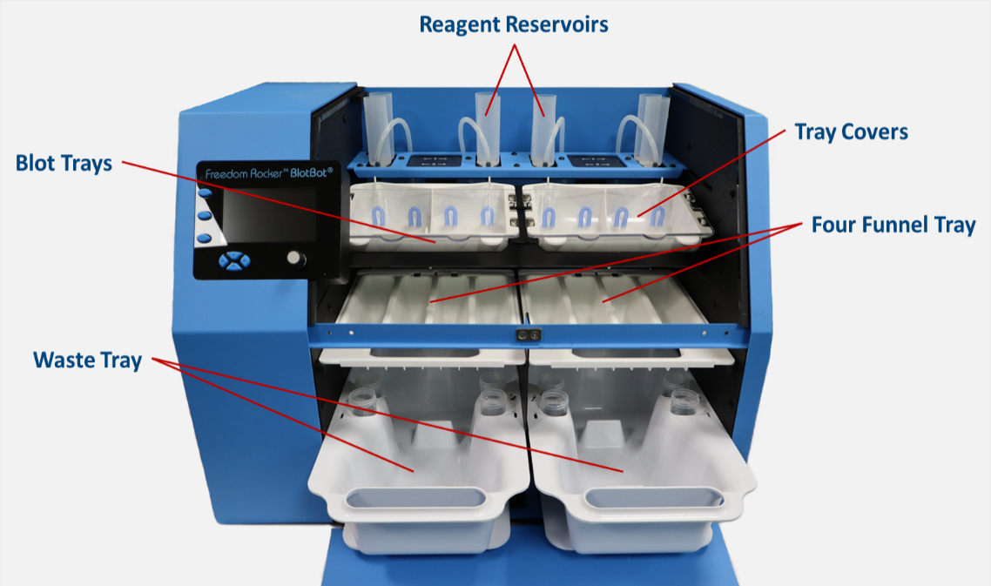Accessories for a fully functional western blot processing station (Image shown: BlotBot 240).

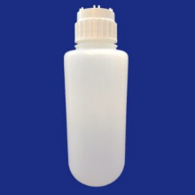Nalgene Bottle with Quick Connect, 2-Liter or 4-Liter

BTLN2-1, BTLN2-2 (Pack of 1 or 2) or BTLN4 (Pack of 1) – Stores buffer for wash steps.

Nalgene 2L bottle with One>Click™ quick connect cap.

Nalgene 4L bottle with One>Click™ quick connect cap.

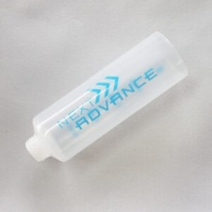Reagent Reservoirs

RRVR-100 (Pack of 100) or RRVR-500 (Pack of 500).

BlotBot reagent reservoirs store the primary and secondary antibodies, and dispense them at the appropriate steps in the process.

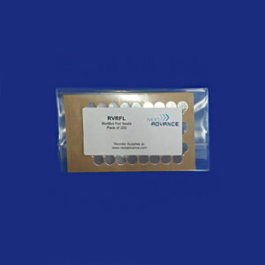Foil Seals for BlotBot Reservoirs

RVRFL (Pack of 200).

Foil seals for reagent reservoirs. Seals allow reservoirs to be reused.

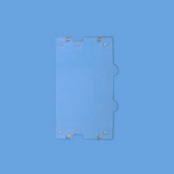Tray Covers

TRAY-WCVR-2 (Pack of 2).

Cover uses magnets to secure blot trays, ensuring they remain in place during processing.

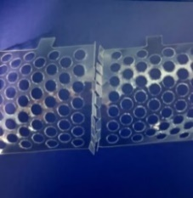Gel Retainers

GLRT-10 (Pack of 10).

Gel retainers prevent protein gels from flipping or folding over during the staining and de-staining process. Use when staining the gels in Miniblot Trays.

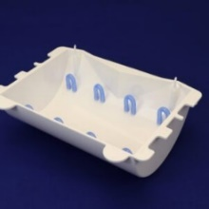Midiblot Trays

TRAY-WMID-2 (Pack of 2).

Tray has 3 cutouts on each side flange and 8 silicone rubber guards.

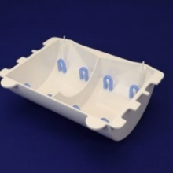Miniblot Trays

YTRAY-WMNI-2 (Pack of 2).

Miniblot Tray holds 2 miniblots in separate compartments. Tray has two separate compartments, 3 cutouts on each side flange and 8 silicone rubber guards.

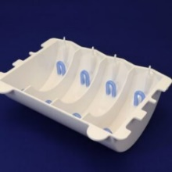Strip Blot Trays

TRAY-WSTRP-2 (Pack of 2).

Strip blot tray for BlotBot 248 and 248V models. Holds up to 4 strips per tray. Has 4 separate compartments, 3 cutouts on each side flange and 8 silicone rubber guards.

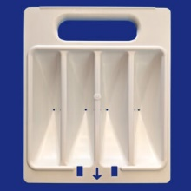Four Funnel Tray

TRAY-4FNL (Pack of 1).

Funnel tray for the BlotBot. Directs the western blot reagents either to waste or recover tubes.

50 mL Recovery Tubes

RRVR-20 (Pack of 20) or RRVR-100 (Pack of 100).

50 mL recovery tubes are placed in waste tray compartments. Antibody reagents are directed into the tubes for recovery.

20 mL Recovery Tubes

TUBE20ST-8 (Pack of 8) for BlotBot 248 and 248V models.

20 mL recovery tubes are placed in the waste tray holders (HLDR-REC). Antibody reagents are directed into the tubes for recovery.

Waste Tray with collection tubes for antibody recovery

TRAY-WASTE and HLDR-REC; Collects buffer waste and holds the recovery tubes for reagent recovery.

TRAY-WASTE uses 4 – 50mL tubes – used with model 240.

TRAY-WASTE with HLDR-REC uses 4 – 50mL tubes and 4 – 20mL tubes – used with models 248 and 248V.

